COLLEGE MANAGEMNT APPLICATION

Day 1: 03/01/2022

Topic: Create your salesforce developer org to get started

Milestone / Activities: Creating Developer Account

Account Activation

Login to your Salesforce Account

Detailed Description: Firstly, I signed up the developer.salesforce.com/. then I filled my data. then it says "the username already in use" then I login into my salesforce account.

Upload the Screenshot the Milestone / Activities:

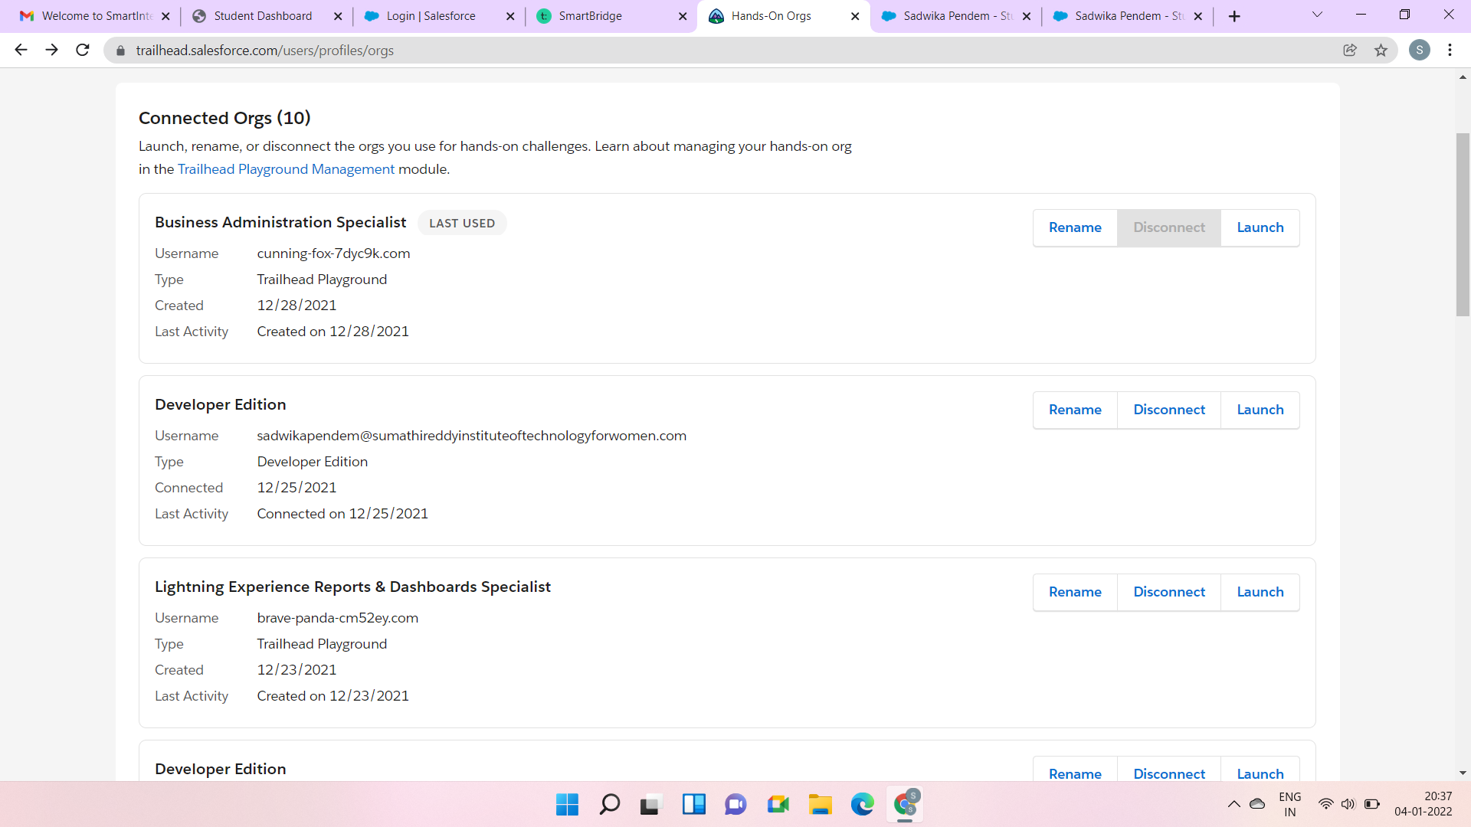

Day 2: 04/01/2022

Topic: Custom Object Creation

Milestone / Activities: Create the Custom Object for the Application

Create Fields on College Object

Create Fields on Application Form Object

Create Fields on Student Object

Create Fields on Subject Object

Detailed Description: firstly I logged in into my salesforce account then I went to Hands-on-ord "Developer Edition" and I tapped on launch. here I created the Custom Objects of Four. inside those Custom Objects I created the fields individually with respect to Custom Objects.

Upload the Screenshot the Milestone / Activities:

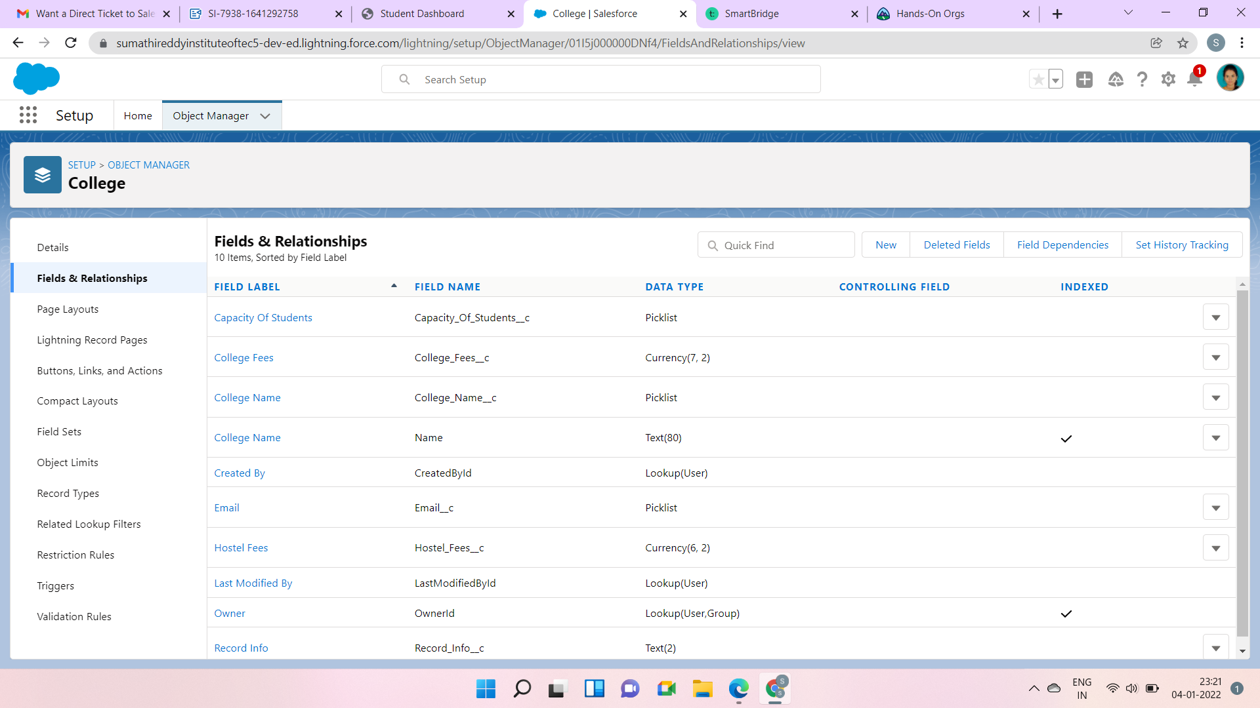

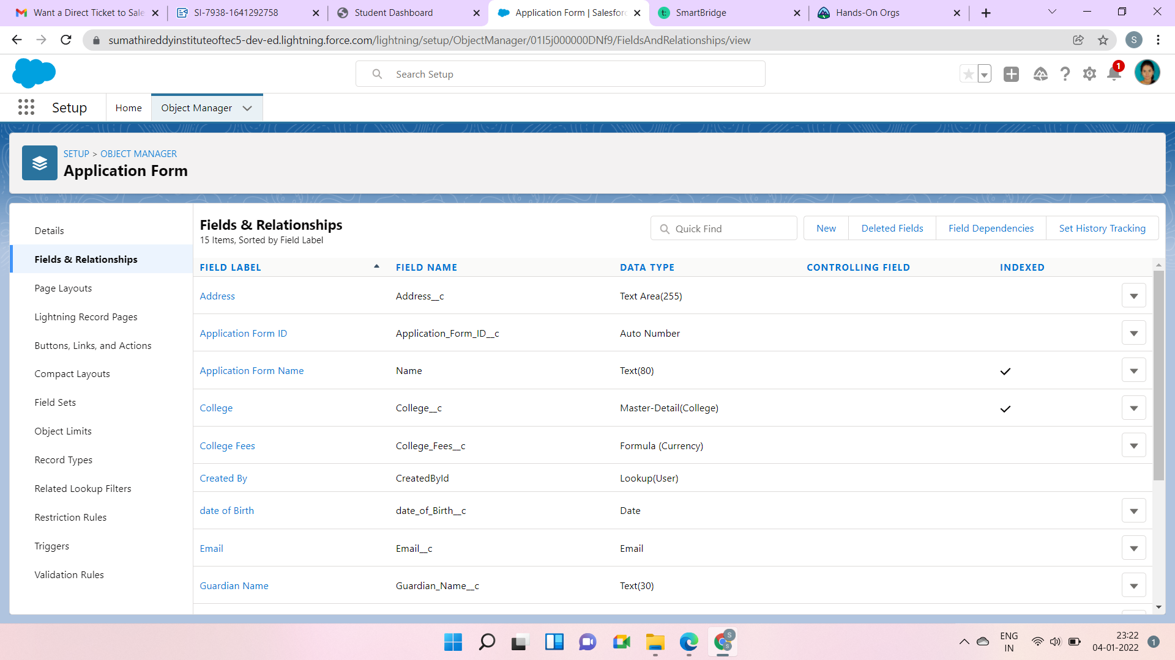

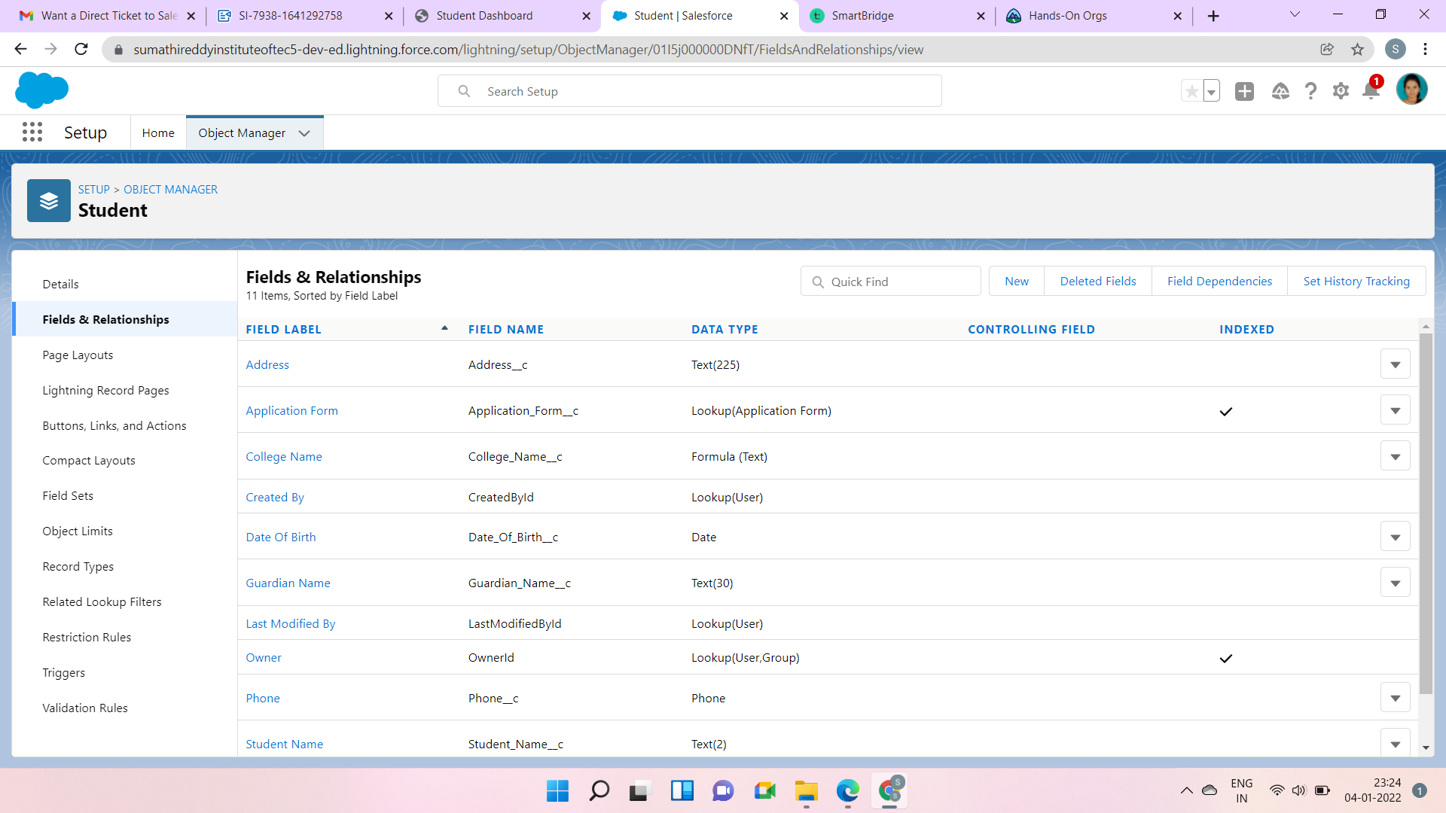

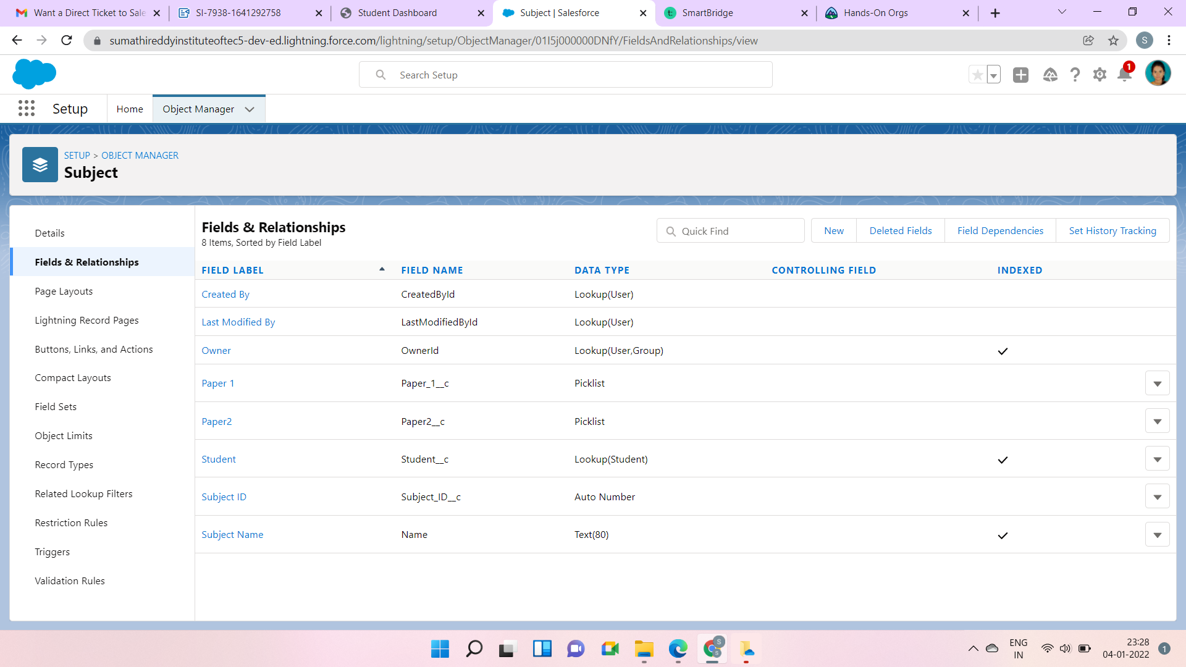

Day 3: 05/01/2022

Topic: Adding Business Logic to Application

Milestone / Activities: Creating global Picklist Value Sets

Creating Field Dependencies

Creating Validation Rules

Detailed Description: At First, I searched the Picklist Value Sets in the Quick Find Box. Then I opened the College in the Object Manager. then I created the values in the global picklist values. then I created the Two field dependencies in the college object. Lastly, I created the validation rules in the college object application by entering the Error syntax in the syntax box

Upload the Screenshot the Milestone / Activities:

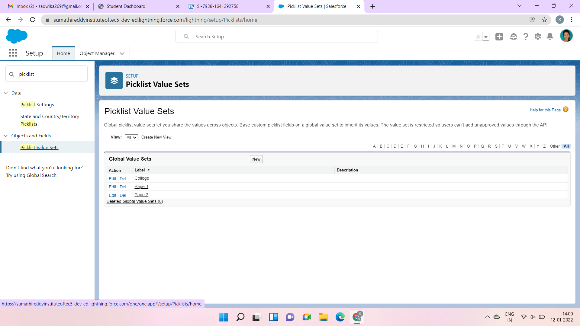

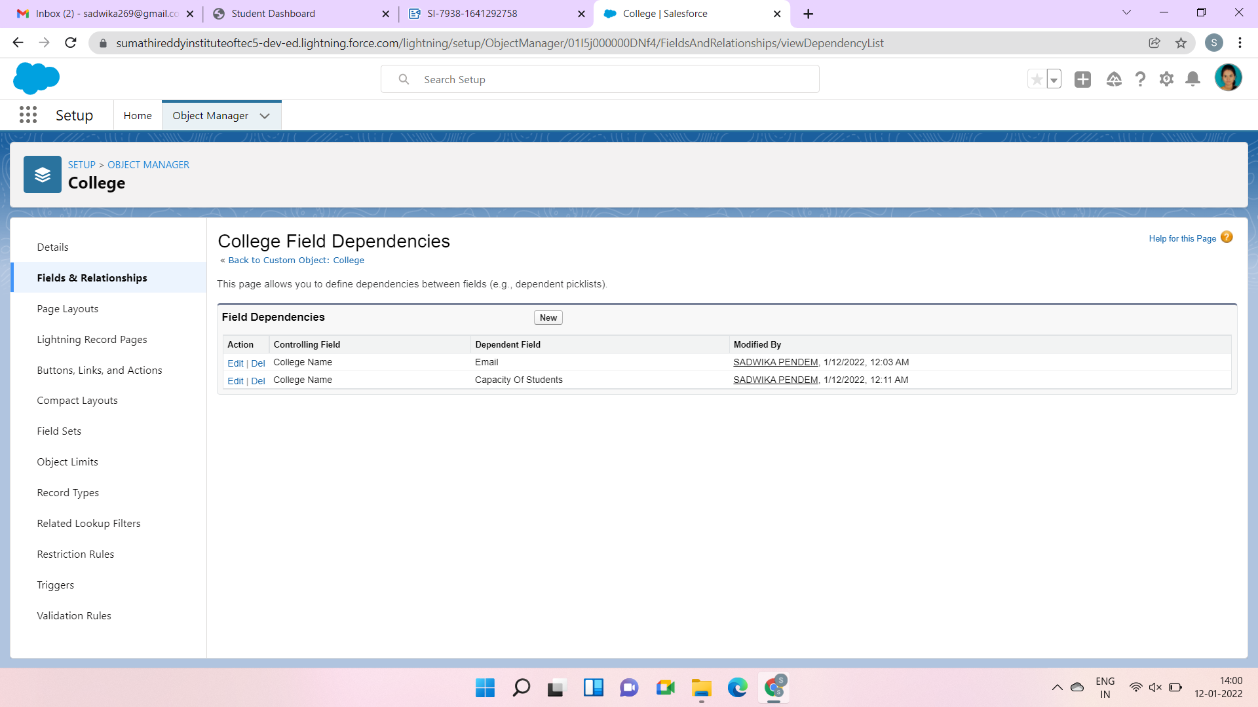

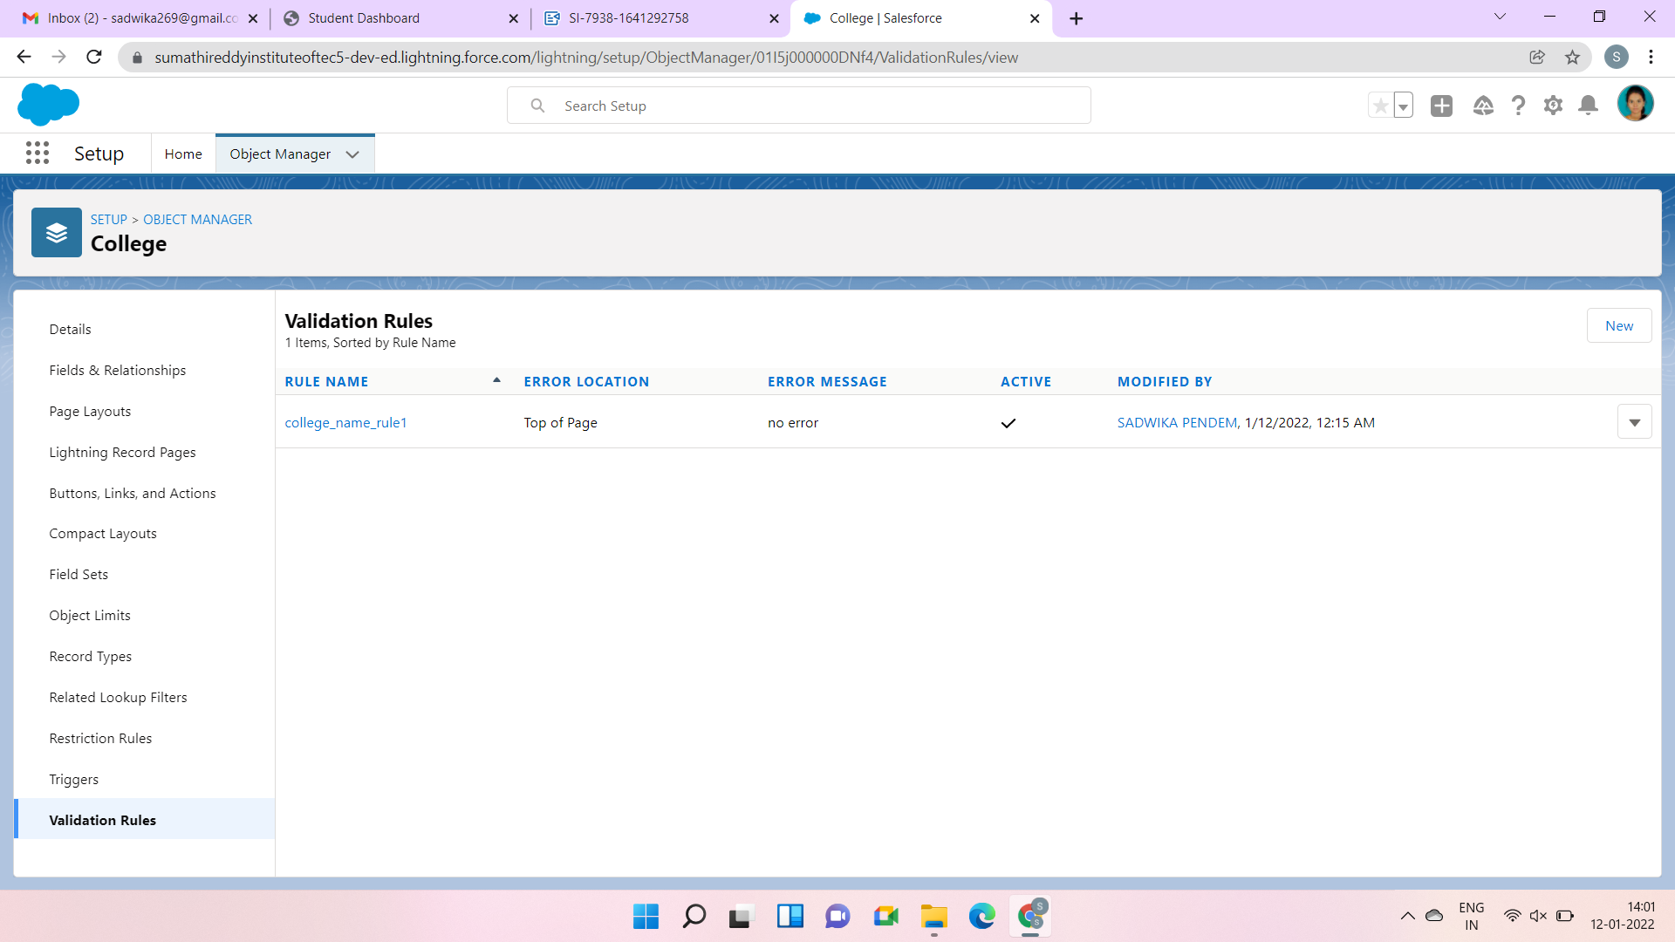

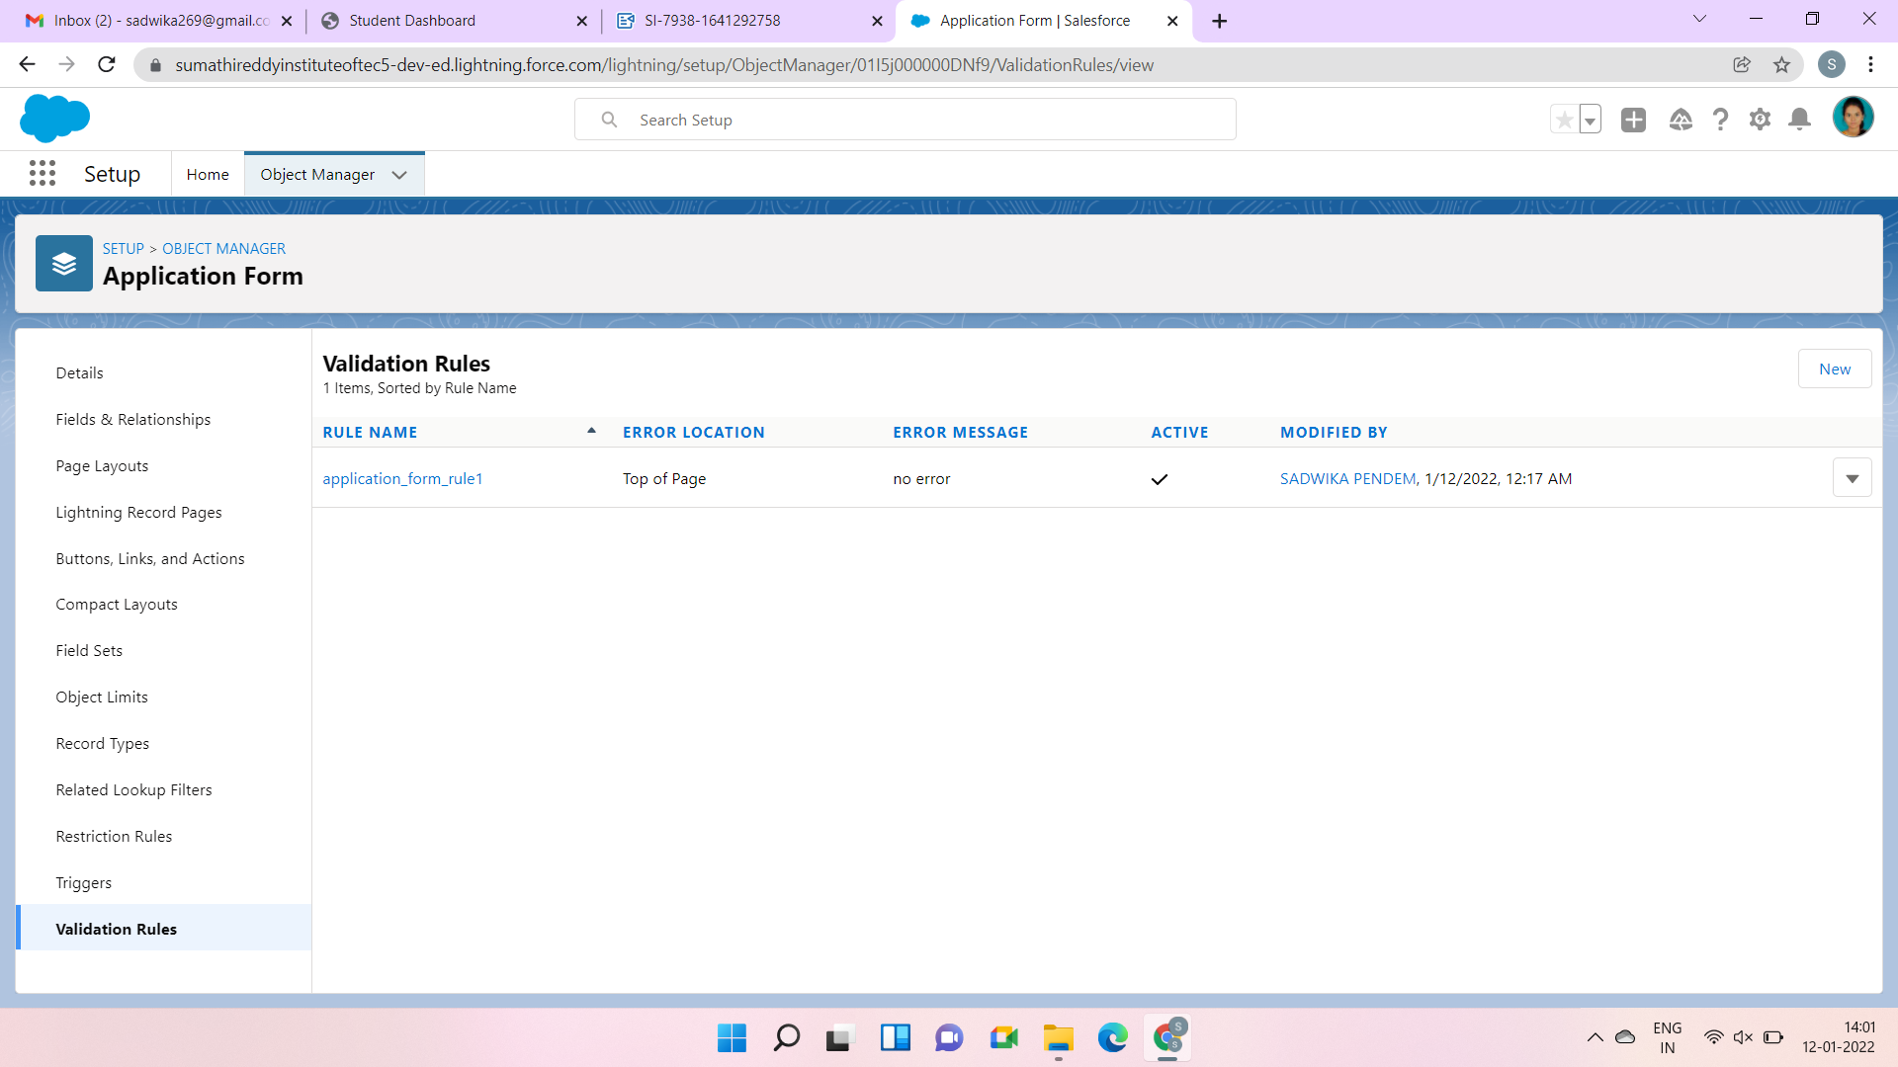

Day 4: 06/01/2022

Topic: Adding Business Logic To Application

Milestone / Activities: Process Automation

Detailed Description: At First, I searched the Process Builder in Quick find box to create the builder and I named it. then created the Add criteria and Nodes as Application form. then I created the immediate action as Create Record. then I saved the builder. and activated it.

Upload the Screenshot the Milestone / Activities:

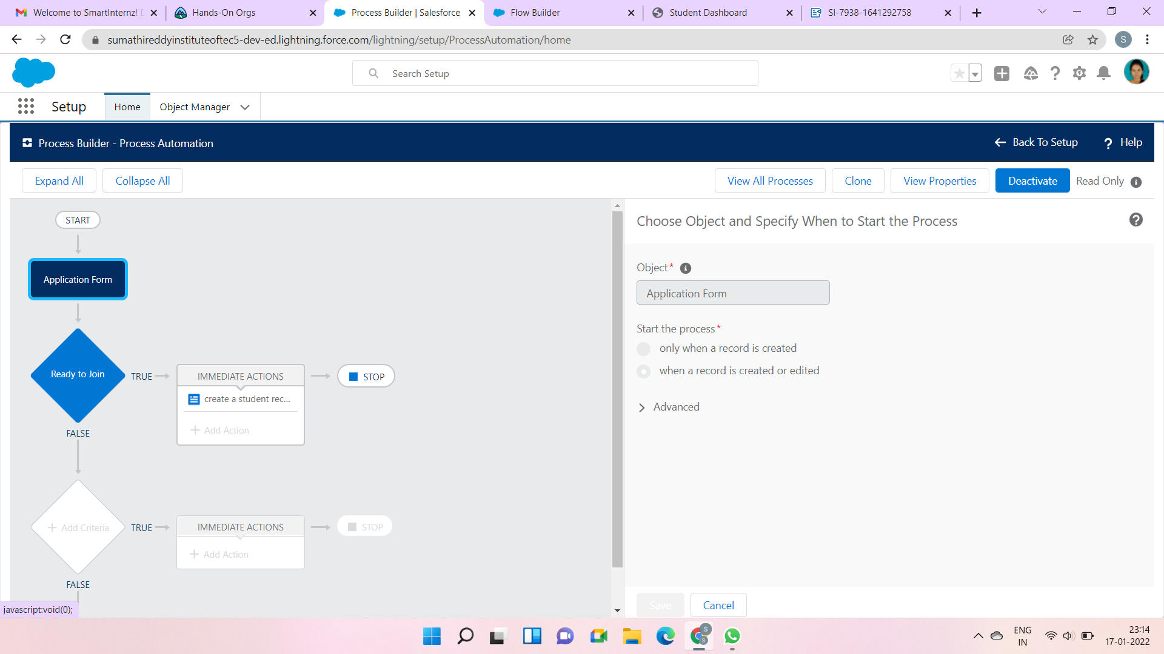

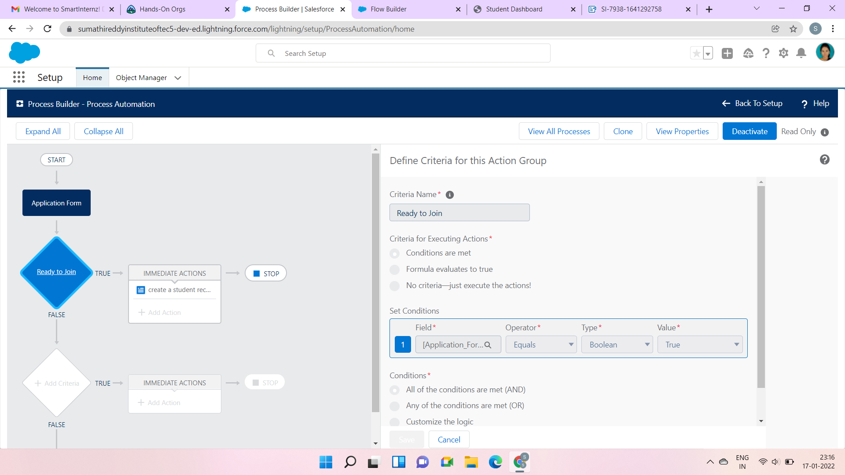

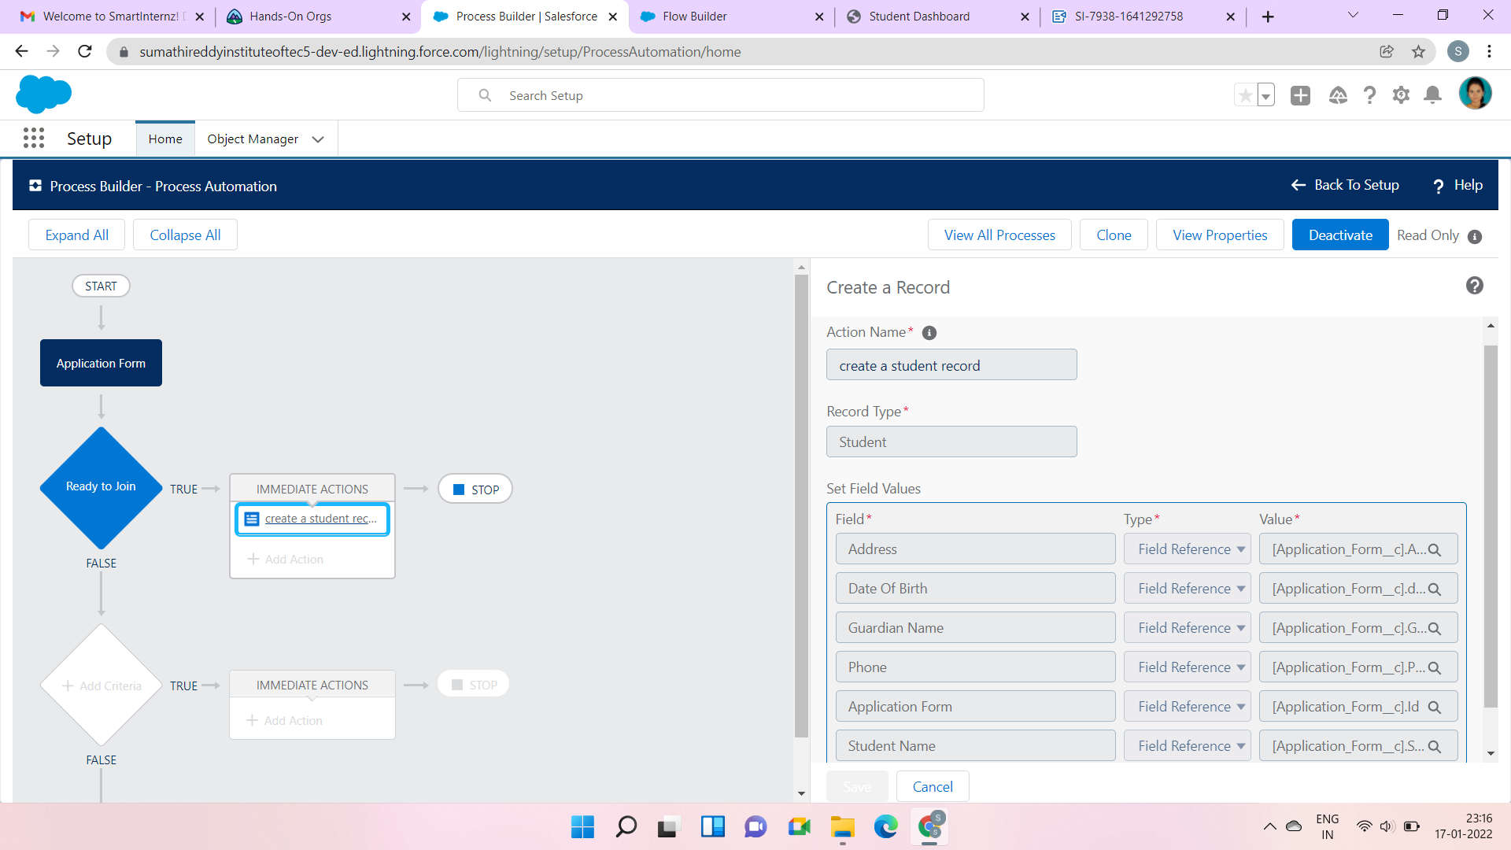

Day 5: 07/01/2022

Topic: Adding Business Logic To Application

Milestone / Activities: Create The Student Record Using Flow

Detailed Description: Firstly, I deactivated the Process Builder which I creates earlier. and I searched for Flows in the Quick find box and tapped the Flows. Selected New Flows, then record triggered Flow. for object I selected the application form. and the configure trigger is selected as when the Record id updated for entry criteria select as ready to join operator is equals and the value is True. Next, I created a variable named student in the resource section. I dragged the assignment and added the assignment in the flow then I created the field and operator and the values. then I saved the block. then I dragged the Create record section from the palette and added the value. then I kept ON the Auto Layout (Beta). at last I saved the floe and Activated the Flow.

Upload the Screenshot the Milestone / Activities:

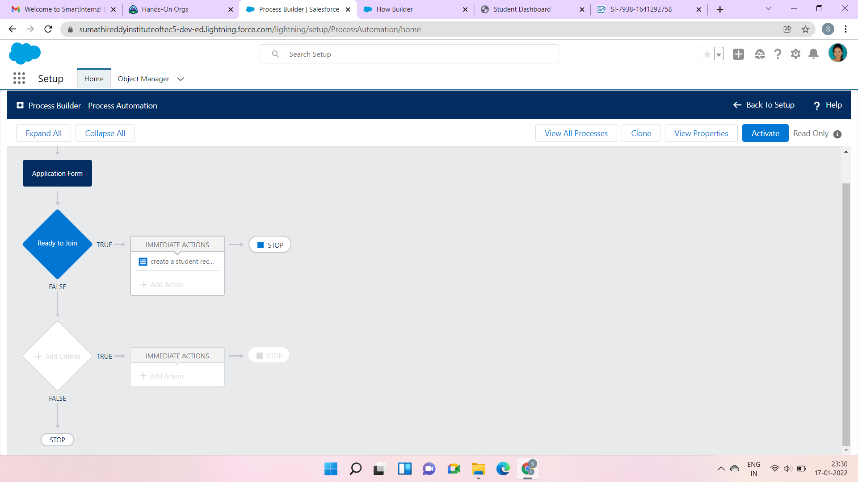

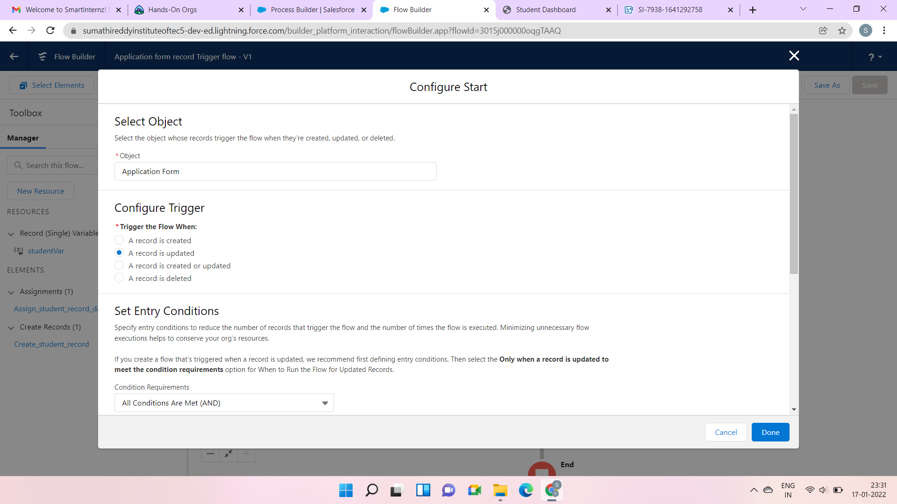

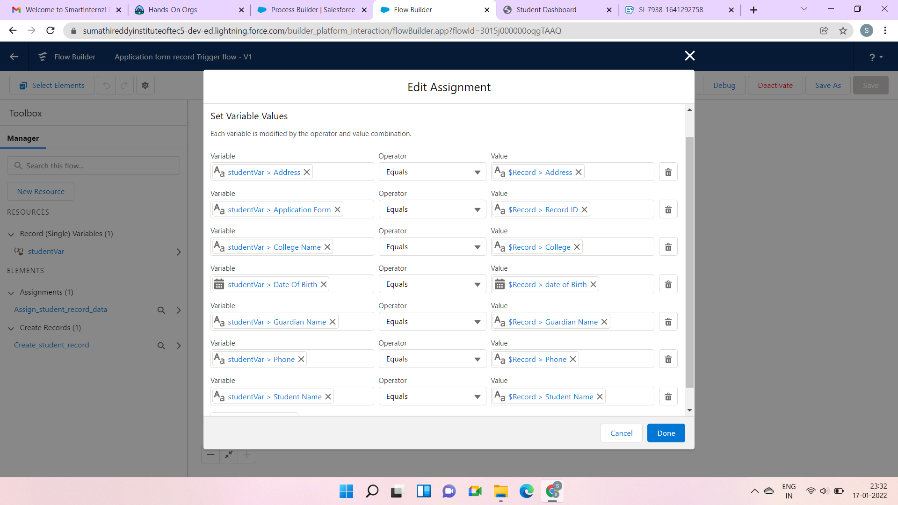

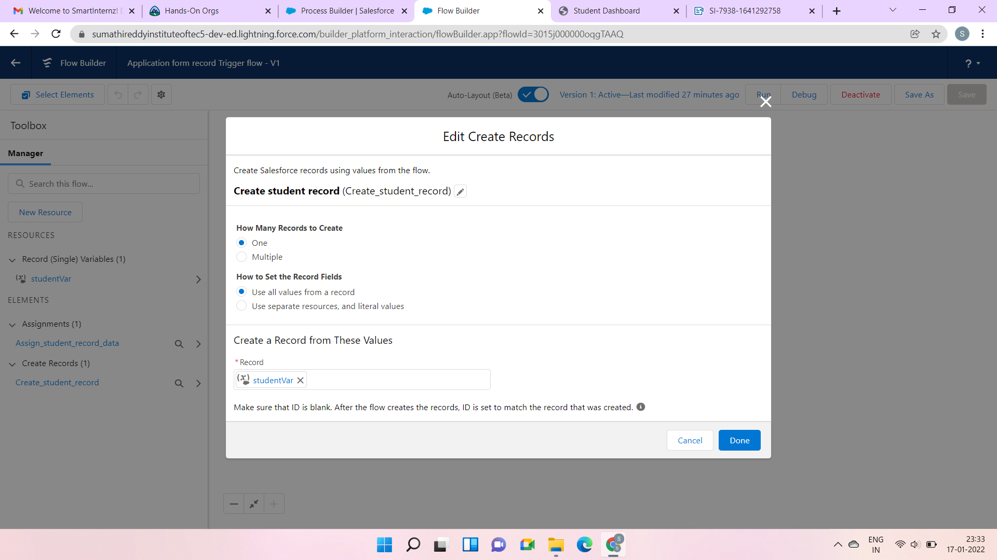

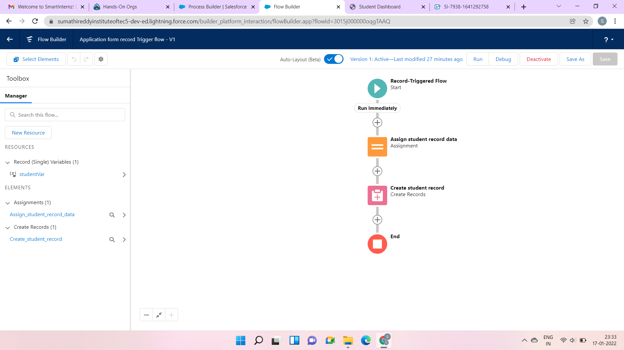

Day 6: 10/01/2022

Topic: Batch Apex

Milestone / Activities: Create Batch Apex For Application Form

Create A Schedular Class

Detailed Description: I logged in to the developer Console and created Apex Class named ApplicationBatchTest. and entered the Apex Class Code. then I clicked the ctrl+e then I entered the code. and I Executed. then I created the ApplicationSchedule for Apex Class and entered the code.

Upload the Screenshot the Milestone / Activities:

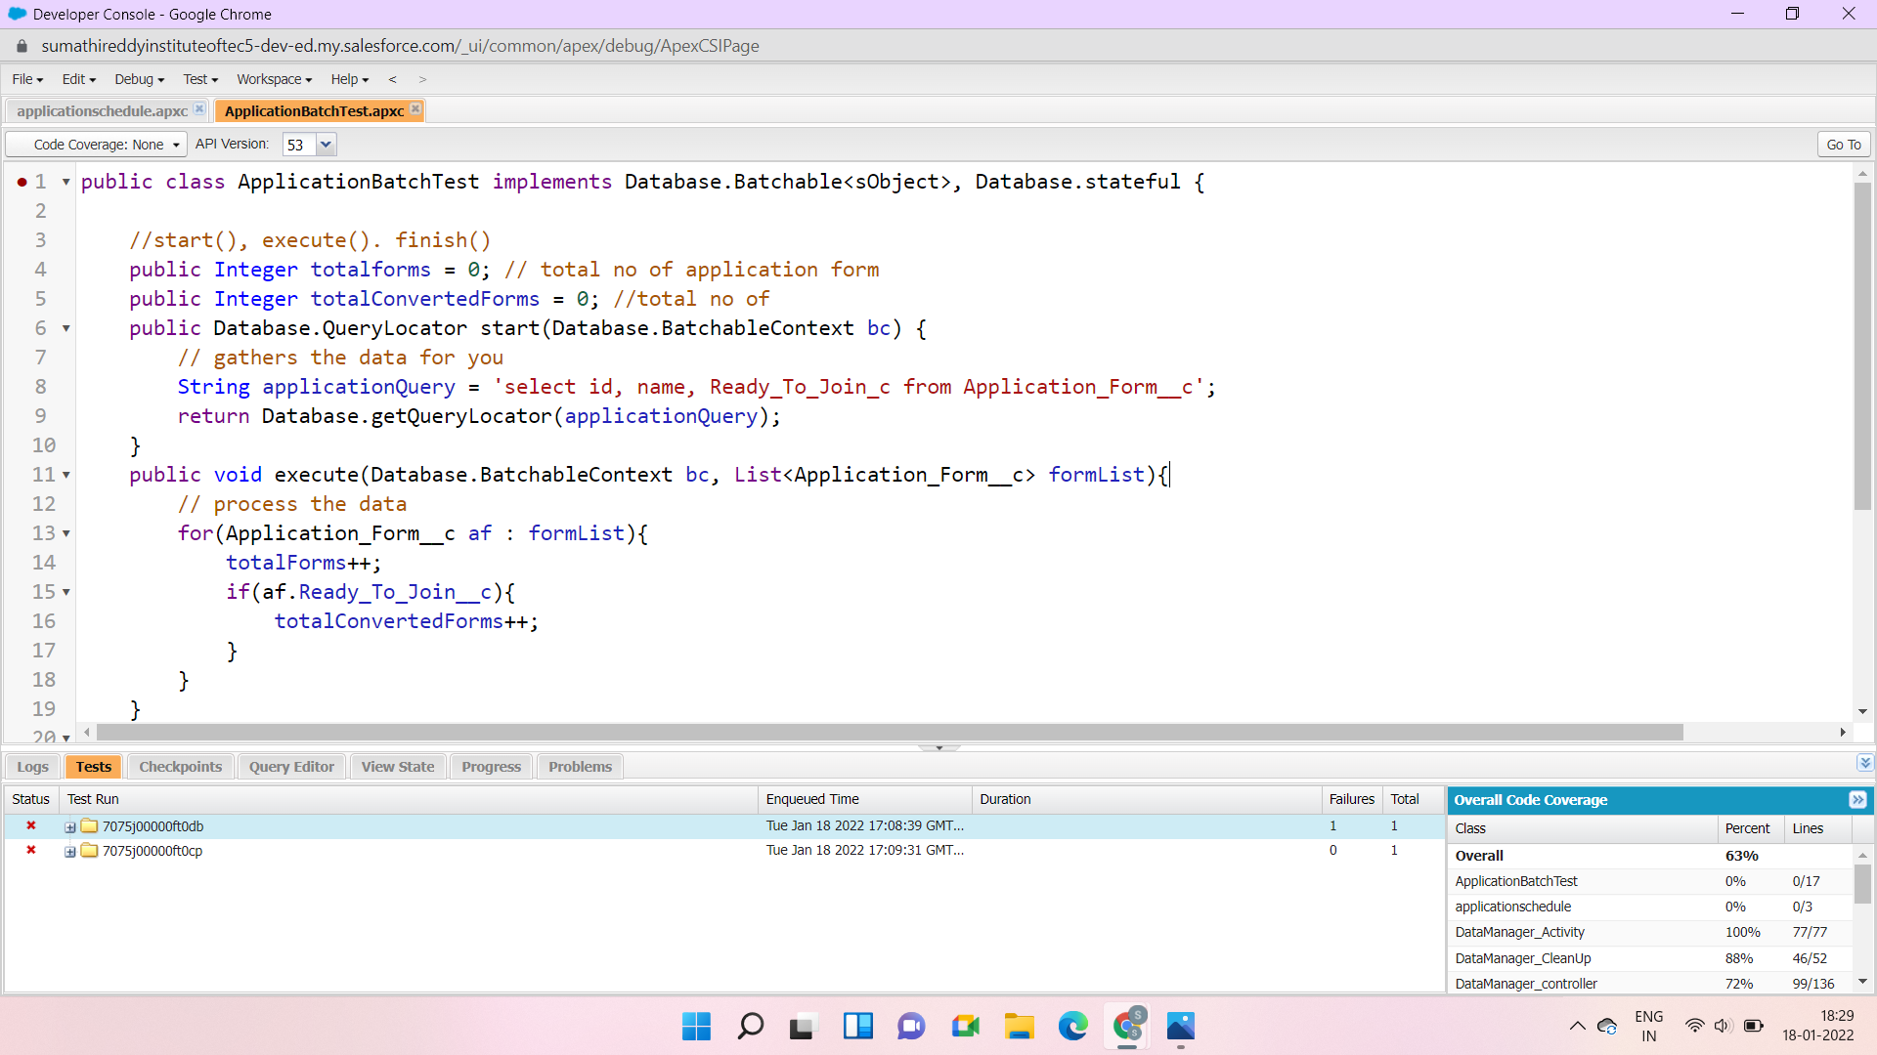

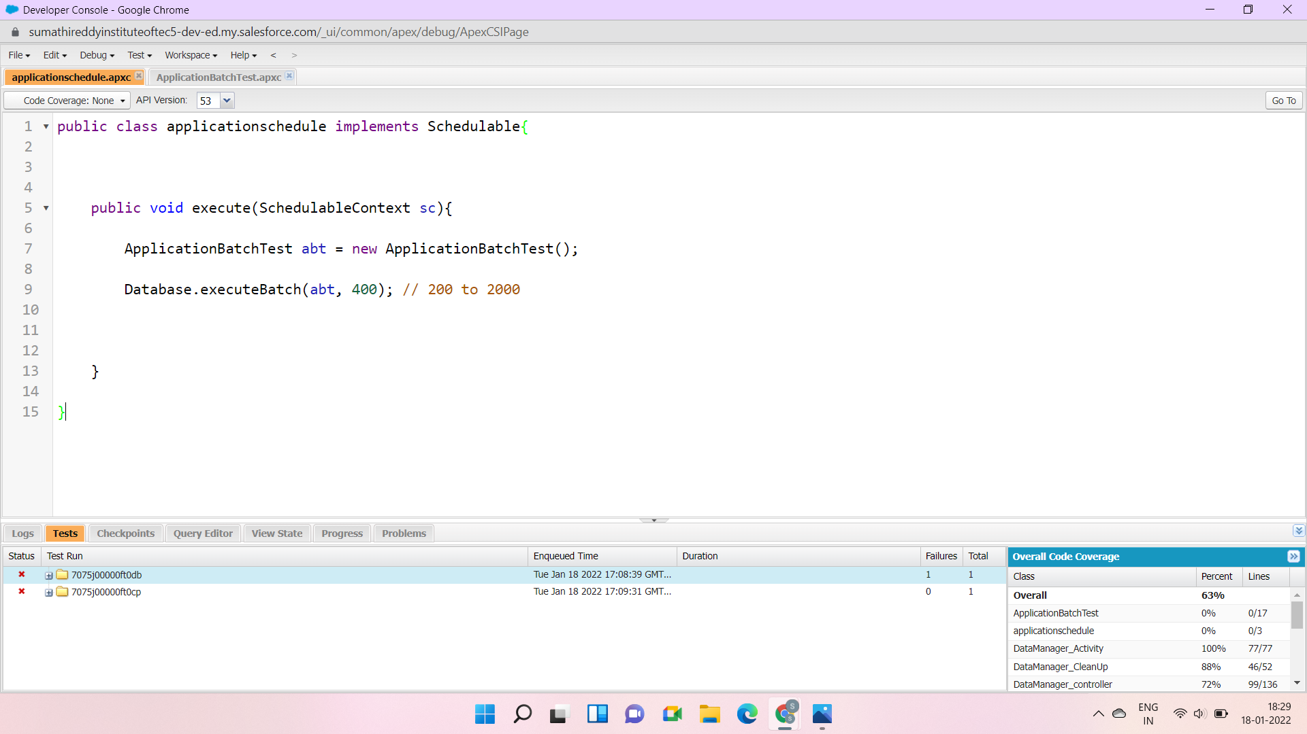

Day 10: 17/01/2022

Topic: Lightning Web Components

Milestone / Activities: Create College Data Table Component (APEX CLASS)

Create College Data Table Component (HTML FILE)

Create College Data Table Component (JAVASCRIPT FILE)

Create College Data Table Component (META FILE)

Detailed Description: I have created the apex class named GAT Application details I developer console, then I download and install the vscode and created the HTML FILE, JAVA SCRIPT FILE, META FILE.

Upload the Screenshot the Milestone / Activities:

